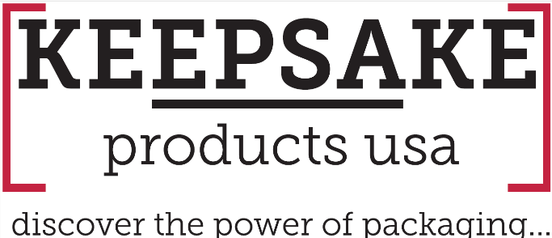

BETTER BY DESIGN…The Keepsake Difference©
How One Material Change Creates a More Complete Packaging Experience
By Cliff Quicksell, CSP, MAS+, MASI
In packaging, the smallest details often make the biggest difference.
The sharpness of the graphics. The feel of the material. The moment the box is opened. Even the appearance of an exposed edge. Individually, these details may seem minor. Collectively, they determine whether a package simply holds a product or elevates the entire presentation.
At Keepsake Products USA, we're constantly looking for ways to improve those details, not simply for our benefit, but for the distributors who trust us with their clients' brands.
That's the thinking behind our move to TripleCore White™ Corrugated.
A Better Canvas Creates a Better Finished Product
Keepsake's high-end, full-color digital printing gives distributors enormous creative freedom. Full-bleed graphics, bold colors, intricate designs and photographic imagery can transform corrugated packaging into a powerful extension of a client's brand.
But great printing deserves a great canvas.
TripleCore White™ provides a bright white exterior designed to complement premium digital printing and create a clean foundation for color and graphics. The result is packaging with the polished, refined appearance today's brands increasingly expect.
But the difference doesn't stop with what's printed on the outside.
White Outside. White Inside. Clean White Edges.
Traditional two-sided white corrugated can appear white on both exterior surfaces while still having a kraft-colored corrugated core. Once the material is cut, folded and constructed, that brown core can become visible along exposed edges.
TripleCore White™ changes that.
- The exterior is white.
- The interior is white.
- And the exposed corrugated edges are white.
That creates a more consistent appearance throughout the entire package. From the first impression to the moment the recipient opens the box, the presentation feels intentional and complete.
This isn't a coating or surface treatment. It is an actual material upgrade.
Because the Experience Doesn't End When the Box Is Opened
Think about what happens with premium packaging.
The recipient first sees the exterior. Then they open the package. The interior becomes part of the experience. The edges, folds, printing and construction are suddenly visible together.
That's where details matter.
A beautifully printed exterior can create an impressive first impression, but a clean white interior and white edges help carry that impression through the entire unboxing experience.
For distributors, that's an important distinction.
You're not simply providing your client with a box. You're helping them create an experience around their brand, product, event, promotion or message.
And when the finished product looks better, you look better to your client.
An Upgrade Without an Upcharge
There is another part of this story that we're particularly proud of.
TripleCore White™ costs Keepsake more than the material it replaces.
We're not passing that additional material cost along to our distributor partners.
Why? Because we believe improvement should be part of the relationship.
When we identify a practical way to improve the quality, appearance, or presentation of the products our distributors take to market, we want to pursue it whenever possible.
TripleCore White™ is a perfect example.
Rather than asking, "How can we make this cheaper?" we asked a different question:
"How can we make the finished product better?"
That decision gives our distributor partners another subtle but meaningful way to distinguish themselves in front of their customers without having to sell an upgrade or justify an additional charge.
Better by Design
TripleCore White™ isn't going to change the way you sell packaging. It's going to change the quality of what you have to sell.
Better presentation. A cleaner interior. Clean white edges. A stronger canvas for Keepsake's full-color digital printing. And a more complete finished package, without an increase in price.
That's what Better by Design means to us.
It's not about changing something simply because we can. It's about continually asking whether there's an opportunity to make the product better, help our distributor partners deliver more value and ultimately help their customers' brands stand out.
Sometimes innovation is a dramatic new idea.
Sometimes it's simply paying attention to the details others might overlook.
TripleCore White™ Corrugated.
A better canvas. A better presentation. A better experience.
At no additional cost.
That’s the Keepsake Difference©
For more ideas, visit: https://keepsakeproductsusa.com/
Interested in more information contact:
Keepsake Products USA
(973) 816-2324
info@keepsakeboxusa.com

