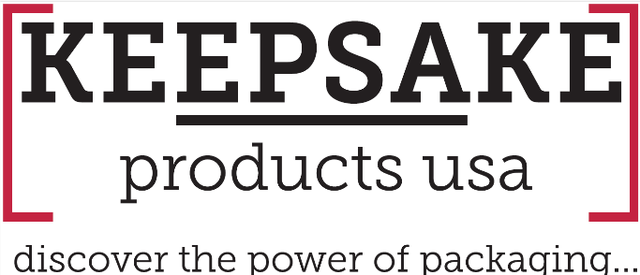
How Promotional Products Distributors Win Bigger Programs with Custom Packaging.

In today’s crowded promotional products landscape, the distributors who consistently win bigger programs have one thing in common:
They’ve stopped selling products.
They’re selling experiences.

While many are still competing on item price and quick-turn quotes, top-performing distributors are shifting the conversation—focusing on how everything comes together, not just what’s inside the box.

That shift is where custom packaging becomes a true game changer.

A product on its own is easy to compare, easy to price-check, and easy to replace.

An experience, however, is something entirely different.

When multiple items are combined into a thoughtfully designed, cohesive presentation, they become something clients can feel—something that tells a story, reinforces a brand, and leaves a lasting impression.

This is where distributors begin to separate themselves.

They’re no longer asking:
“What products do you need?”

They’re asking:
“What experience are you trying to create?”

Perception drives value.

The same products, when presented in custom packaging, immediately feel more premium, more intentional, and more impactful. A well-designed box, branded inserts, and structured presentation can transform even simple items into something elevated.

As perceived value increases, so does what clients are willing to spend.

Packaging doesn’t just hold products—it enhances them.

Custom packaging makes it easy to turn individual items into complete, high-impact programs.

Instead of selling a t-shirt, a notebook, and a water bottle separately, you’re delivering:

- A new hire onboarding kit
- A curated client appreciation gift
- A fully branded event mailer

Bundling creates cohesion. It adds meaning. And most importantly, it increases the overall size and scope of the order.

This is how smaller transactions become larger, more strategic programs.

First impressions matter—and in many cases, the unboxing is the moment that matters most.

A thoughtfully designed package builds anticipation, creates a sense of occasion, and turns a simple delivery into an experience. From the texture of the box to the way each item is revealed, every detail shapes how the brand is perceived.

These moments stick.

They’re shared. Remembered. Talked about.

That’s something a standalone product rarely achieves.

As Andy Griffin, Managing Partner at Keepsake Products USA, puts it:
“Once packaging enters the conversation, you are no longer selling stuff—you are selling a solution.”

That’s the shift.

When packaging becomes part of the strategy, you move beyond transactions and into something far more valuable. You’re no longer just fulfilling an order—you’re helping clients solve a problem, tell a story, and create a meaningful connection.

The distributors winning bigger programs aren’t winning because they have better products.

They’re winning because they’re delivering better experiences.

By leveraging custom packaging, they:

- Elevate perceived value
- Bundle items into high-impact programs
- Create memorable, shareable moments

And in doing so, they move from being vendors to becoming true partners.
If you’re still leading with products, you’re leaving opportunity on the table.

Start with the experience—and let packaging bring it to life.
For more ideas, visit: https://keepsakeproductsusa.com/
Interested in more information contact:
Keepsake Products USA
(973) 816-2324
info@keepsakeboxusa.com

